SVCR GOVERNMENT DEGREE COLLEGE PALAMANER
STUDENTS FEED BACK ON CURRICULUM 2025-26
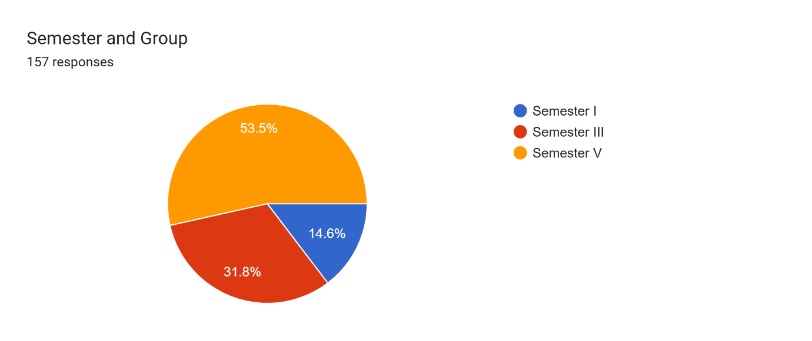
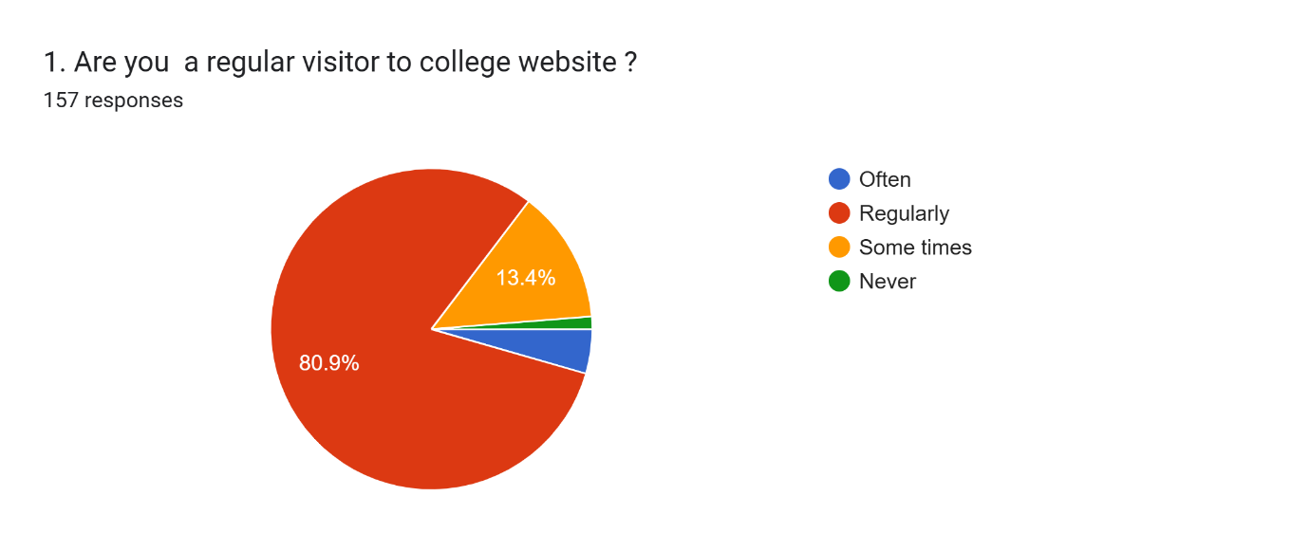
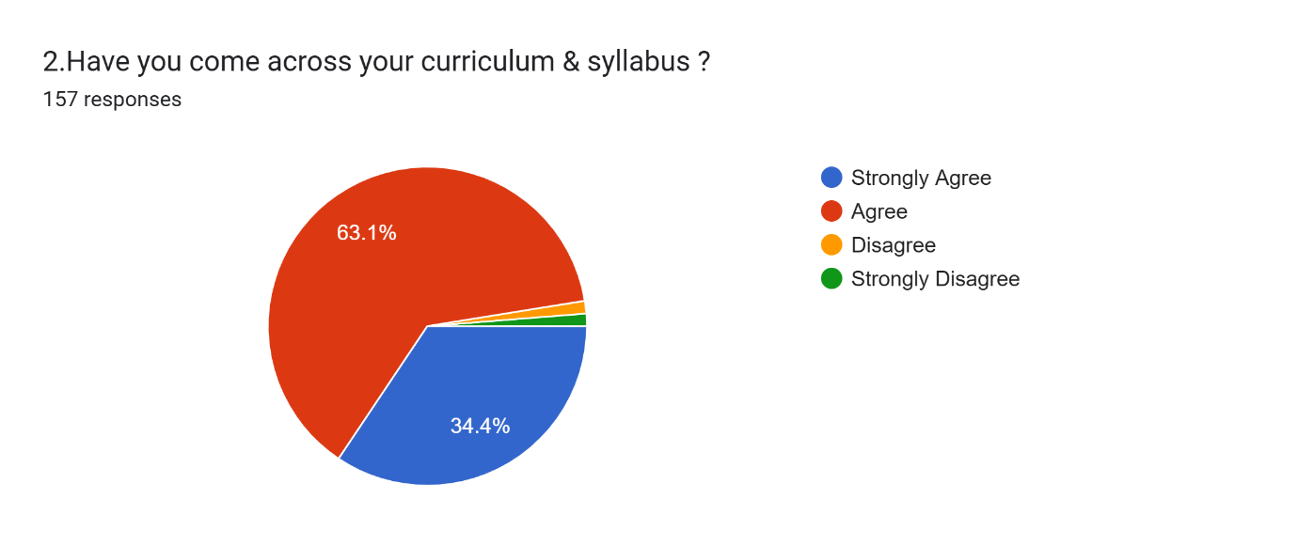
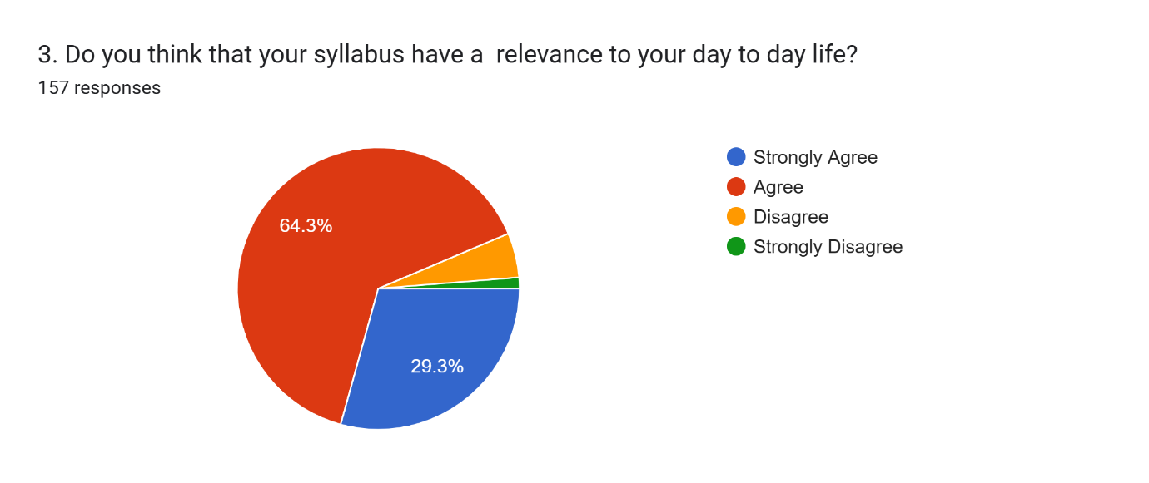
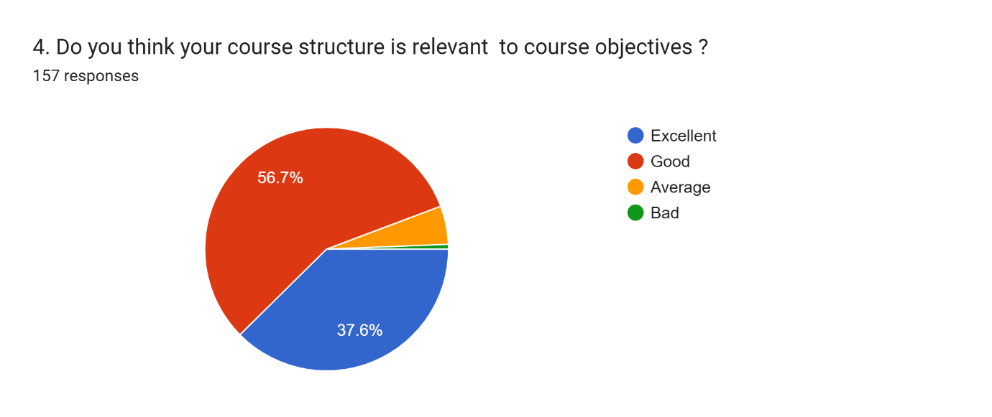
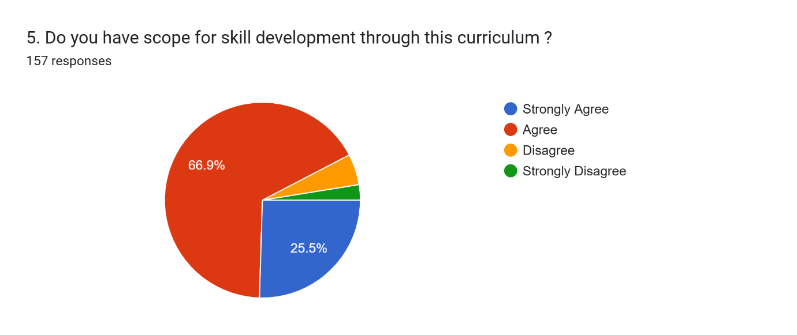
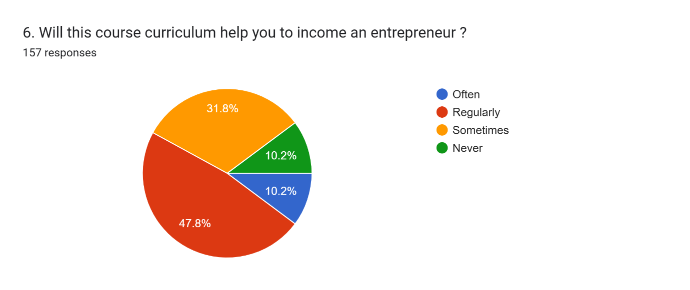
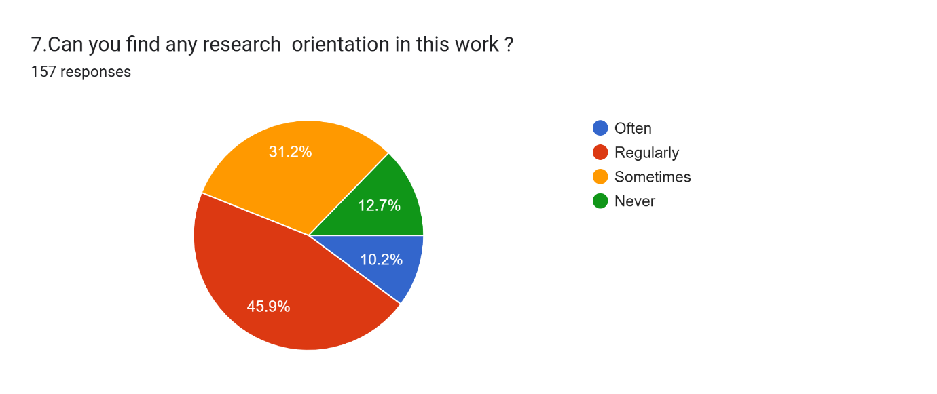
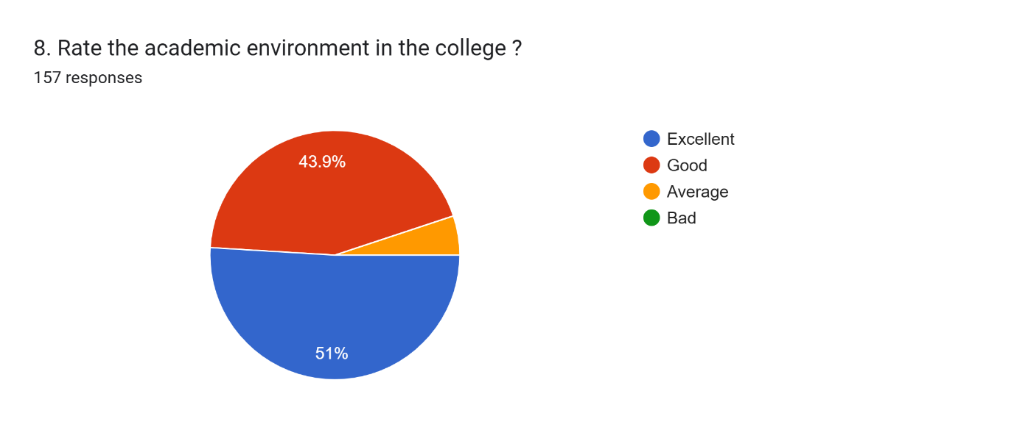
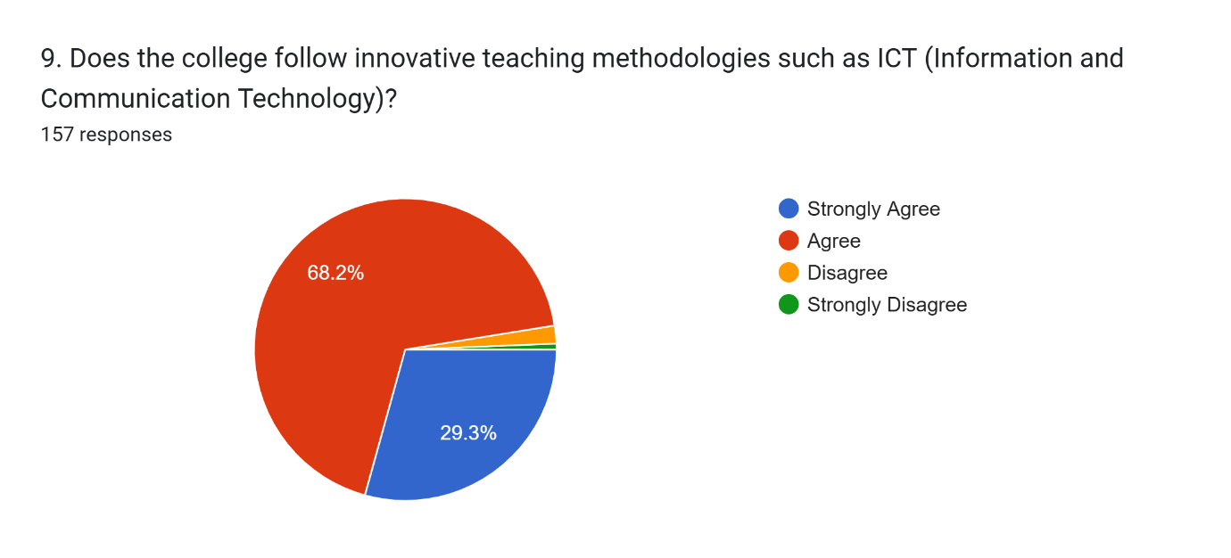
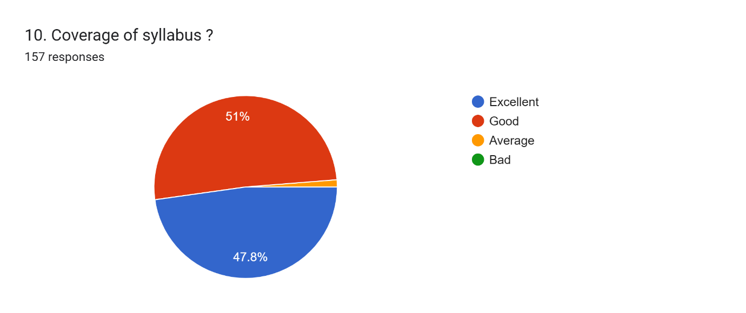
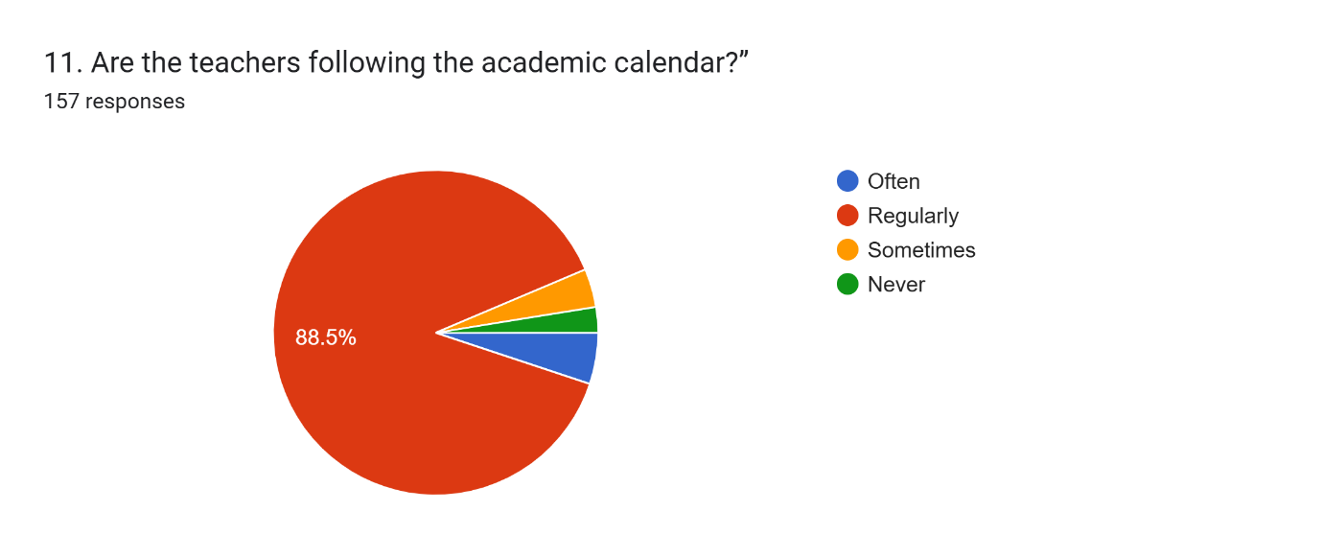
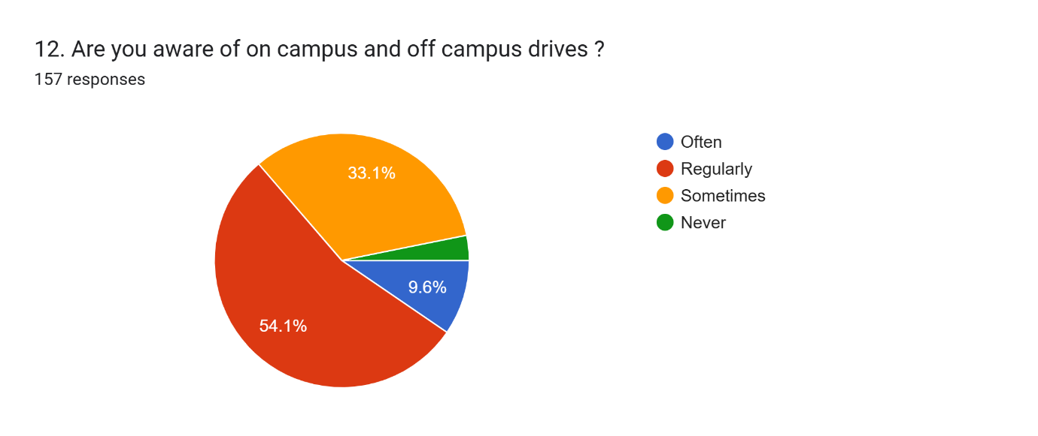

Consolidated Feedback Report: Students' Feedback on Curriculum (2025-26)
Total Respondents: 157

Summary
The feedback collected for the 2025-26 academic year reveals a high level of student satisfaction regarding the academic environment and teacher adherence to schedules. While the core curriculum and syllabus coverage are rated positively, there is a notable opportunity to strengthen research orientation and awareness of career-focused placement drives.

Student Profile
The survey respondents were distributed across different stages of their education:
- Semester V: 53.5%
- Semester III: 31.8%
- Semester I: 14.6%

Curriculum & Academic Environment
Students expressed strong confidence in the college's academic structure and the relevance of their studies:
Category | Key Metric | Result
Academic Environment | Rated as "Excellent" | 51%
Syllabus Coverage | Rated as "Good" | 61%
Course Structure | Relevant to objectives ("Good") | 56.7%
ICT Integration | Agree that innovative methods are used | 69.2%
Academic Calendar | Teachers follow it "Regularly" | 88.5%

Skill Development & Career Readiness
While general feedback is positive, the data suggests areas for career-oriented growth:
- Skill Development: 66.9% of students "Agree" that the curriculum provides scope for developing skills.
- Entrepreneurship: 47.8% believe the curriculum "Regularly" helps them toward becoming an entrepreneur, but a significant 31.8% feel it only does so "Sometimes".
- Placement Awareness: Only 9.6% are "Often" aware of on-campus and off-campus drives, with 54.1% being "Regularly" aware.
- Research Orientation: This is a primary area for improvement, as only 10.2% "Often" find research orientation in their work, while 12.7% "Never" find it.
Key Observations
- Strong Digital Presence: 80.9% of students are regular visitors to the college website.
- Syllabus Relevance: A majority (64.3%) agree that the syllabus is relevant to their day-to-day life.
- High Engagement: Combined "Strongly Agree" and "Agree" ratings for syllabus awareness reach 97.5%.

Conclusion
The student feedback for the 2025-26 academic year at SVCR Government College, Palamaner reflects a robust and well-functioning academic ecosystem. The following points summarize the findings:
- Academic Discipline: There is high satisfaction with teacher consistency, as 88.5% of students report that the academic calendar is followed regularly.
- Curriculum Satisfaction: The majority of students (97.5%) are aware of their syllabus and find it relevant to their daily lives.
- Infrastructure & Innovation: The college successfully integrates technology, with 78.2% of students agreeing that innovative ICT teaching methodologies are employed.
- Developmental Gaps: While general academic sentiment is "Excellent" (71%), there is a visible need to enhance research orientation and entrepreneurial guidance to better prepare students for post-graduate challenges.
- Communication: The college website serves as a primary information hub, accessed regularly by 80.9% of the student body.
Overall, the curriculum is meeting its core objectives, though targeted improvements in placement awareness and research initiatives would further elevate the institutional standard.

